2
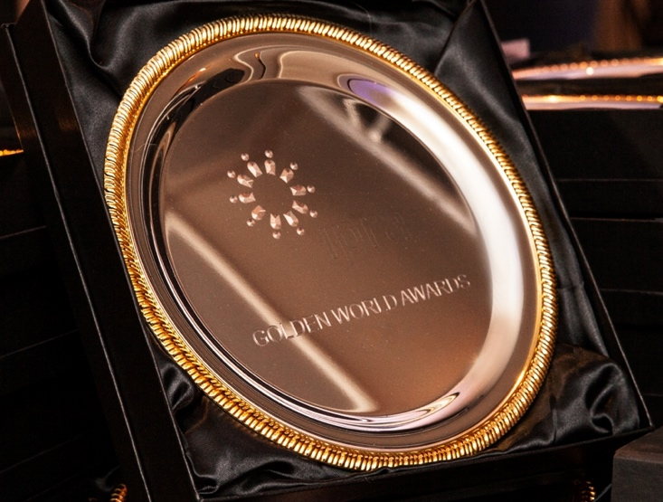 | 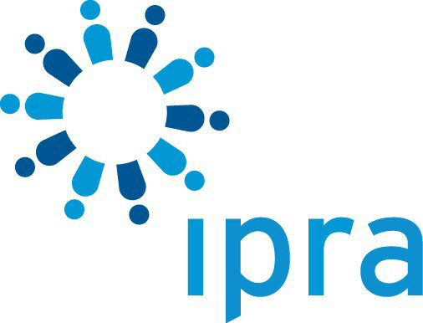

IPRA Golden World Awards for Excellence 2025 Entry Kit
This entry kit is a set of complete instructions on how to enter the world’s most prestigious public relations awards scheme.

The annual IPRA Golden World Awards for Excellence in Public Relations (GWA), was established in 1990, and recognizes eminence in public relations practice worldwide in a variety of categories. Recipients of the award take particular pride in the recognition granted to their Entry as meeting international standards of excellence in public relations. The IPRA Grand Prix for Excellence is presented to the Entry judged as representing the highest standard of the year. A Global Contribution Award is given for the Entry best meeting one of the UN’s 17 sustainable development goals. While there are many national and regional PR awards, there is only one truly global scheme: the GWA.

Contents

1. Background to the GWA 2
2. Dates and Deadlines 2
3. Fees 2
4. Frequently Asked Questions 3
5. Round 1 entry summary template 7
6. GWA Categories 8
7. The Rules 10

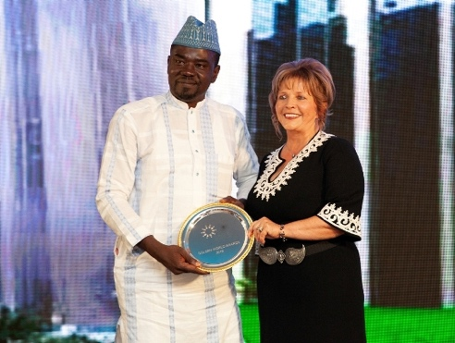 |  | 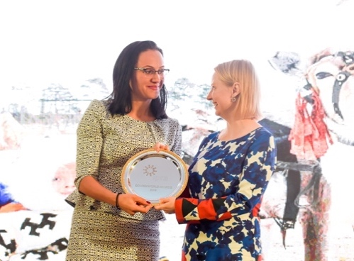

1. Background to the GWA

What are the GWAs?
IPRA’s Golden World Awards for Excellence in Public Relations, established in 1990, celebrates each year the outstanding achievements of global communication professionals. The annual GWAs also bring together the profession and its practitioners and offer a platform for collegial exchange and learning.

Who is the organization behind it?
IPRA, the International Public Relations Association, is the leading global network for public relations professionals. Membership is individual not corporate. It aims to further the development of open communication and the ethical practice of public relations. IPRA fulfils this aim through networking opportunities, its code of conduct, and intellectual leadership of the profession. With 60 years of experience, IPRA, recognised by the United Nations, is now present throughout the world wherever public relations are practiced. IPRA welcomes all those within the profession who share its aim and who wish to be part of the IPRA worldwide fellowship. Through its networks, IPRA represents over 13,000 communications professionals around the world.

2. Dates and Deadlines
Entries open Tuesday 18 February 2025
Entries close Monday 5 May 2025

Please note that an Entry received after 5 May 2025 is ineligible.

3. Fees
The fee is £450 per Entry. There is a discount for an early Entry and a penalty for a late Entry.

Early £420 | Tuesday 18 February – Monday 17 March 2025
Normal £450 | Tuesday 18 March – Monday 14 April 2025
Late £480 | Tuesday 15 April – Monday 5 May 2025

Please note that an Entry unpaid at the start of Round 1 judging will be ineligible.

4. Frequently Asked Questions

1. Who can apply for the GWA?
The GWA is open to all communication professionals, from such diverse fields as public relations, corporate and internal communications, brand building, and reputation management. Companies, consultancies, associations, institutions, and NGOs can apply. IPRA encourages entries from governments, universities and educational institutions.

2. What are the entry requirements and qualifying dates for entries?
Entries must be submitted to IPRA online at www.ipra.org. Entries must be for a PR Programme that "completed" before the start date of the annual competition. The Programme may have started one or more years before this. By "completed" we mean that you must have enough information to be able to provide answers to criteria 6 "Outcomes".

3. Agency or In-House?
If you enter as an agency you MUST go into the Agency type and fill in the field Client.
Only enter In-house if you are a company, NGO, government or similar. Entries in the wrong type will be moved.

4. How many entries may I make?
You may submit an unlimited number of entries. We recommend that each Entry is entered both as a PR Discipline and as a PR sector to increase your chance of winning. Each Entry attracts an entry fee.

5. How do I choose a Category and can I put the same Entry in multiple Categories?
IPRA has created an online Keywords GWA Category generator to help you choose the Categories for your Entry. Just tick as many Keywords as you like that are appropriate for your Entry and the generator will provide a set of Category options. It is a good idea to put your Entry into multiple Categories. This increases your chances of winning. Each Entry attracts an entry fee.

6. What are payment methods for entry fees?
After Entry, you will be directed to a payment page with options to pay with a credit card. You receive an invoice link by email immediately after payment. You can add a billing address.

7. Are there discounts?
Yes. By special arrangement with certain national organisations.

8. Who are the Judges?
The IPRA GWA Judges are leading communications professionals from around the world, representing companies, agencies, associations, institutions, and universities. See the website for their profiles.

9. Are Judges barred from entering the GWA?
No. However Judges are barred from judging an Entry in the Category they have submitted.

10. What am I judged on?
Each Entry in Round 1 is judged on the basis of 6 criteria. The total number of words for all 6 criteria must be a maximum of 1800. Follow the word-length guidelines for each criteria. For the Round 1 entry summary the criteria are the following.

1. Overview (100 words)
- Summarise the Programme and tell the whole story as if you were writing a press release: Client (if applicable), country, problem or opportunity, creative execution, outcome.

2. Problem or Opportunity (200 words)
- State your Organisation (and your Client if applicable)
- Problem or opportunity addressed
- Geographical area of the Programme
- Measurable objective by which success is to be evaluated.

3. Research (300 words)
- To define the problem or opportunity
- To determine approaches for the Programme.

4. Planning (400 words)
- Communications objectives and tactics planned
- Target audiences to be reached and actions desired of them
- Messages planned for target audiences.

5. Execution (400 words)
- The key creative solution
- Implementation of the communications plan
- Difficulties encountered and adjustments made during implementation.

6. Outcomes (400 words)
- Identification, analysis and quantification of results
- Tangible results which achieved the measurable objectives.
(Please do not include advertising value equivalencies).

11. How does judging take place?
Judging will take place in 2 rounds. After the deadline for entries has passed, our Judges will review the criteria in the Round 1 entry summary and by online voting, create a shortlist of Finalists per Category. The Round 1 entry summary identifies the Finalists who will be invited to upload the Round 2 supporting media. Finalists are then judged against the 6 criteria in the summary and the supporting media. In considering entries, the Judges may select one, several or no awards in each Category. The IPRA Grand Prix and the Global Contribution Award will also be selected by the Judges.

12. What content is expected in the Round 2 supporting media?
In Round 2 supporting media, Finalists must upload:
- 1 A4 Illustrated PDF
- 1 copy of your Organisation logo
- 1 copy of your Client logo (if applicable)
- 2 promotional images of your Entry.
- 1 link to a video (option).

Tips:
- Round 1 judging takes 14 days. Finalists then get 14 days to upload supporting media.
- The Illustrated PDF. Repeat the text from the Round 1 entry and add photographs and video links (if available). The Illustrated PDF will be used to judge the Winners. Do NOT include confidential information.
- PDF maximum size = 5MB and max 5 pages. Images maximum size = 1MB.
- Use the "Embedded Media" field to paste a URL of a Youtube or Vimeo video of your Entry. You cannot upload the video itself to IPRA.

13. When do I hear about GWAs awarded?
The Judges final selection in each Category will be announced after the judging in June or July. The Grand Prix and the Global Contribution Award will not be revealed until the GWA Gala towards the end of the year.

14. What does the GWA trophy look like?
A custom-designed GWA trophy plate will be presented to all winners at the Gala. Winners may purchase additional trophy plates directly from IPRA.

15. Are any special awards given?
Yes. There is a Grand Prix for the best PR campaign of the year. There is a special Global Contribution Award for an Entry with an objective of meeting one of the UN's 17 sustainable development goals.

16. When are the awards presented to winners?
The Winners will be announced and presented with their Trophies at the IPRA GWA Gala which takes place in changing locations and venues around the world at the end of the year. You will also receive a GWA winners’ logo to use on your website. And you may order extra Trophies to be sent after the Gala. Finalists receive Certificates.

17. What if I can’t make it to the Gala: how do I collect my Trophy?
Winners who are not at the Gala may order their Trophy from IPRA. You will only be charged for shipping.

18. Can I get feedback from Judges on my Entry?
Due to the high number of entries, IPRA is not able to give individual feedback.

19. Can the Judges disqualify entries?
Yes. The Judges or Secretariat may disqualify an entry if the content could be challenged by the IPRA Code of Conduct, or if the rules and structure for an Entry are not followed.

20. The language of the GWA
For clarity we define certain words as follows.
GWA | The International Public Relations Association Golden World Awards for Excellence in Public Relations.
Programme | The PR campaign that you completed.
Entry | The information on your Programme that you send to IPRA for the GWA.
Agency (entry type) | An Entry for a Programme conducted by a PR or communications agency for the objectives of its client.
Inhouse (entry type) | An Entry for a Programme conducted by the employees of an organisation for its own objectives. (If this information is sent in by an Agency, the entry will be moved to an Agency entry type.)
Category | A series of designations of PR by Discipline and Sector
Category group | PR Discipline or PR Sector
Round 1 entry summary | A maximum of 1800 words divided into 6 Criteria. Text only.
Criteria | A guideline of 6 divisions to help structure the Entry, submitted as the Round 1 entry summary.
Finalist | An Entry that has been selected by the Judges on the basis of the Round 1 entry summary.
Round 2 supporting media | 1 Illustrated PDF, 2 images, logos, 1 video link: giving complete information on the Entry uploaded by Finalists.
Winner | An Entry that has been selected by the Judges on the basis of the Round 1 entry summary and the Round 2 supporting media.
Gala | An evening event with a dinner and entertainment held at the end of the year to celebrate Winners and present their trophies.

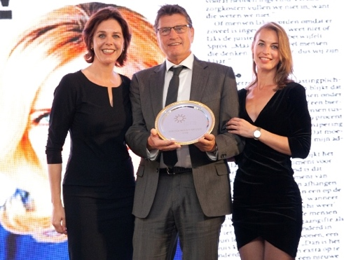 |  | 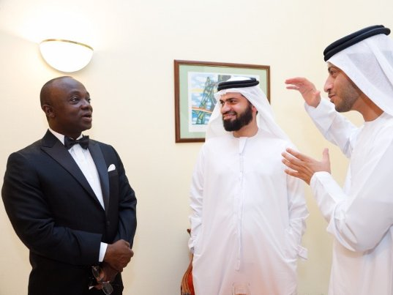

5. Round 1 entry summary template
You can use the form below to prepare your Round 1 entry summary offline. Then copy and paste when you go online.

Entry title (50 characters):

1. Overview (100 words):

- Summarise the Programme as if you were writing a press release: client (if applicable), problem or opportunity, creative execution, outcome
2. Problem or Opportunity (200 words):

- State your Organisation (and your Client if applicable)
- Problem or opportunity addressed
- Geographical area of the programme
- Measurable objective by which success is to be evaluated
3. Research (300 words):

- To define the problem or opportunity
- To determine approaches for the programme
4. Planning (400 words):

- Communications objectives and tactics planned
- Target audiences to be reached and actions desired of them
- Messages planned for target audiences
5. Execution (400 words):

- The key creative solution
- Implementation of the communications plan
- Difficulties encountered and adjustments made during implementation
6. Outcomes (400 words):

- Identification, analysis and quantification of results
- Tangible results which achieved the measurable objectives.
(Please do not include advertising value equivalency).

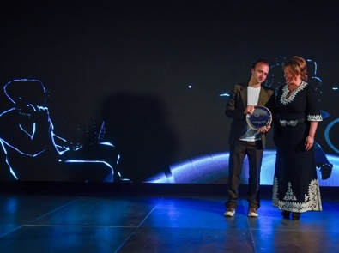 |  | 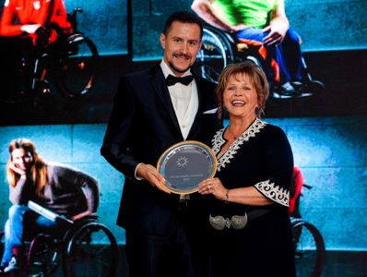

6. GWA Categories
For the 49 categories Agency and In-house are judged separately. Agencies may not submit In-house entries. Categories are grouped into PR Disciplines and a PR Sectors. Entrants are encouraged to enter each campaign into each group.

PR Disciplines
1. Artificial Intelligence for content AICONTENT
For the use of AI in the content of a PR campaign.

2. Artificial Intelligence for crisis management AICRISIS
For excellence in deploying AI tools to respond to a crisis in real time.

3. Artificial Intelligence for measurement AIMEASURE
For innovative use of AI data analytics to measure effectiveness.

4. Climate change and literacy CLIMATE
For a PR campaign on climate change issues or education.

5. Community relations COMREL
For a PR campaign that helped engage a community in some specific way.

6. Corporate communications CORPCOM
For excellence in enhancing a company’s reputation through communications.

7. Corporate responsibility CORPRES
For a PR campaign demonstrating excellence in corporate social responsibility.

8. Crisis and issues management CRISIS
For excellent communications management during a crisis or similar issue.

9. Digital and social media creativity DIGITAL
For a purely digital PR campaign showing creativity in its use of social media.

10. Environmental ENV
For a PR campaign on an environmental or ecological issue.

11. Environmental, social, and governance ESG
For a campaign using an ESG framework to understand sustainability.

12. Influencer relations INFLUENCE
For a PR campaign where the result was largely determined by social media influencers.

13. Integration of traditional and new media INTEG
For the creative integration of traditional and social media in a PR campaign.

14. Internal communications INTERNAL
For a creative internal communications campaign that engaged personnel.

15. International campaign INTL
For a coordinated PR campaign in more than one country.

16. Media relations MEDIA
For a PR campaign which showed impressive media reach.

17. Podcasts and video POD
For a PR campaign that primarily used podcasts or short video.

18. PR on a low budget PRLOW
For a creative PR campaign on a low budget.

19. Public affairs PUBLICAF
For lobbying that influenced or changed public policy.

20. Reputation and brand management REPUTE
For the creative positioning of a company image or brand.

21. Sustainability communications SUST
For a PR campaign promoting sustainability.

PR Sectors

22. Agriculture AGRI
For a PR campaign in the agricultural or farming sector.

23. Arts and entertainment ARTS
For a PR campaign in arts or entertainment.

24. Business-to-business B2B
For a business-to-business PR campaign.

25. Construction CONSTRUCT
For a PR campaign about construction, real estate or architecture.

26. Consumer product launch CONSUMPRODL
For creative PR activities around the launch of a consumer product.

27. Consumer product PR CONSUMPRODX
For creative PR activities around an existing consumer product.

28. Consumer service launch CONSUMSERVL
For creative PR activities around the launch of a consumer service.

29. Consumer service PR CONSUMSERVX
For creative PR activities around an existing consumer service.

30. Country, region and city COUNTRY
For a PR campaign to promote a country, a region or a city.

31. Courage in communication COURAGE
For a PR campaign addressing political upheaval, conflict or natural disaster.

32. Energy and utilities ENERGY
For a PR campaign in the energy, oil, or utilities sector.

33. Event management and live communication EVENT
For the planning and delivery of a successful event with a PR dimension.

34. Fake news FAKE
For a PR campaign countering misinformation or disinformation.

35. Financial services and investor relations FINANCE
For use of PR for a financial product or service or in investor relations.

36. Food and beverage FOOD
For a PR campaign to promote a new or existing food or beverage.

37. Gaming and virtual reality GAME
For a PR campaign that launched a development in the gaming or VR industry.

38. Healthcare HEALTH
For a PR campaign in the pharmaceutical or healthcare industry.

39. Industrials INDUSTRY
For a PR campaign in materials, mining, chemicals, steel and other heavy industry.

40. NGO campaign NGO
For a PR campaign by a charity or non-governmental organisation.

41. Public sector PUBLICSEC
For creative use of PR by a public sector body.

42. Publications PUBLT
For a creative PR publication in print or electronic format.

43. Retail and fashion RETAIL
For a PR campaign in the retail or fashion sector.

44. Small and medium enterprises SME
For a PR campaign by an SME (as defined by the EU).

45. Sponsorship SPONSOR
For a PR campaign that promoted awareness of sponsorship of an event or activity.

46. Sport SPORT
For a PR campaign to promote sport or exercise for itself or to a community.

47. Technology TECH
For a creative PR campaign in the technology or IT sector.

48. Transport TRANSPORT
For a PR campaign in the automotive or other transport sector.

49. Travel and tourism TRAVEL
For a PR campaign in the travel, hotel or tourism sector.

7. The Rules
The following are the terms and conditions of entry to the IPRA GWA. By submitting entries to the competition, you assent that you have read and agree to abide by these terms and conditions and the additional guidelines in the FAQ.

A. Dates and deadlines
Entries open Tuesday 18 February 2025
Entries close Monday 5 May 2025

Please note that an Entry received after 5 May 2025 is ineligible.

B. Fees
The fee is £450 per Entry. There is a discount for an early Entry and a penalty for a late Entry.

Early £420 | Tuesday 18 February – Monday 17 March 2025
Normal £450 | Tuesday 18 March – Monday 14 April 2025
Late £480 | Tuesday 15 April – Monday 5 May 2025

All fees must be paid at the time of Entry via credit card. You will receive an invoice by email. You may enter a billing address. No refunds are possible for withdrawn entries. An Entry unpaid at the start of Round 1 judging will be ineligible.

{For multiple entries above £1000 in total, payment may be made by electronic transfer to IPRA’s bank account. Contact the IPRA Secretariat first info@ipra.org, pay within 7 days of doing your Entry, and send info@ipra.org a copy of the bank transfer confirmation so we can trace your bank payment. Entries with untraceable bank payments will not be judged.}

C. Point of contact
Every entrant must have a point of contact: a single person with whom we communicate about the Entry. We will send email to the point of contact. The point of contact agrees to:
- whitelist (ensure it does not go to spam) the email address info@ipra.org
- read all email promptly and respond as required
- provide a back-up email that is a different person and senior to the point of contact.

D. Entry
Make your Entry to IPRA online at www.ipra.org

E. Round 1 entry summary
Maximum length: 1800 words.
Language: English.

The Round 1 entry summary has 6 divisions known as the Criteria:
1. Overview (100 words)
2. Problem or Opportunity (200 words)
3. Research (300 words)
4. Planning (400 words)
5. Execution (400 words)
6. Outcomes (400 words)
See the FAQ for a description of each Criteria.

F. Category
Each entrant chooses a GWA Category or Categories. IPRA has created an online Keywords GWA Category generator to help you select the best Categories for your Entry. There is no limit: entries can be put into as many Categories as you believe appropriate. It is a good idea to select at least one Discipline and one Sector per Campaign. This increases your chances of winning. Each Entry attracts a unique entry fee. Judges reserve the right to change the Category if they believe the new Category is more suited to the Entry. In the event of a dispute as to the Category, the decision of the IPRA staff and GWA Judges will prevail.

G. Round 2 supporting media
If your entry is selected as a Finalist you will be notified and asked to supply Round 2 supporting media. Language: English. See the FAQ for details. No supporting media will be returned.

H. Awards
The Judges selection of Winners in each Category will be announced after the judging in June / July. The Grand Prix and the Global Contribution Award will not be revealed until the Gala. A custom-designed GWA Trophy will be presented to all winners at the Gala.

I. Publication of winning entries
As a condition of Entry please note that the illustrated PDF (from the Round 2 supporting media) of each GWA winning entry will be published on the IPRA website after the Gala. Certain entries will also be used to market the following year’s GWA using your text, pictures, and social media handles. This is our way of giving you additional free exposure. Entrants must not include any confidential or non-public information in their Entry.

J. Russian entries for GWA 2025
Further to the IPRA statement of 10 March 2022 in support of the UN General Assembly resolution calling for the end of hostilities in Ukraine, the IPRA Board has resolved to disallow entries from the Russian Federation for the Golden World Awards for Excellence in PR 2025. This action is consistent with the legal requirement upon IPRA from national and international sanctions on Russia.

Failure to comply with these Terms & Conditions and the additional guidelines of the FAQ will make your Entry ineligible.

Good luck!

Any questions?
Contact Janice Hills at info@ipra.org
Telephone: +44 1634 818308.
The office is open Monday to Friday from 08.00 UTC to 17.00 UTC.

